Name- Rhit Manandhar

Student ID- 30359612

# Process Model

AI based Credit Mapping tool application must help students fasten their transfer credit process by replacing the manual registers. It should have upload section, validation section and unless all the documents are successfully accepted application should be on hold. After the submission of the document, administration staff must be notified by the system. If any further documents are required, students must be able to submit their documents via the system. The process ends with the acceptance or rejection of the credit transfer application.

This is a brief business process model diagram of the overall project.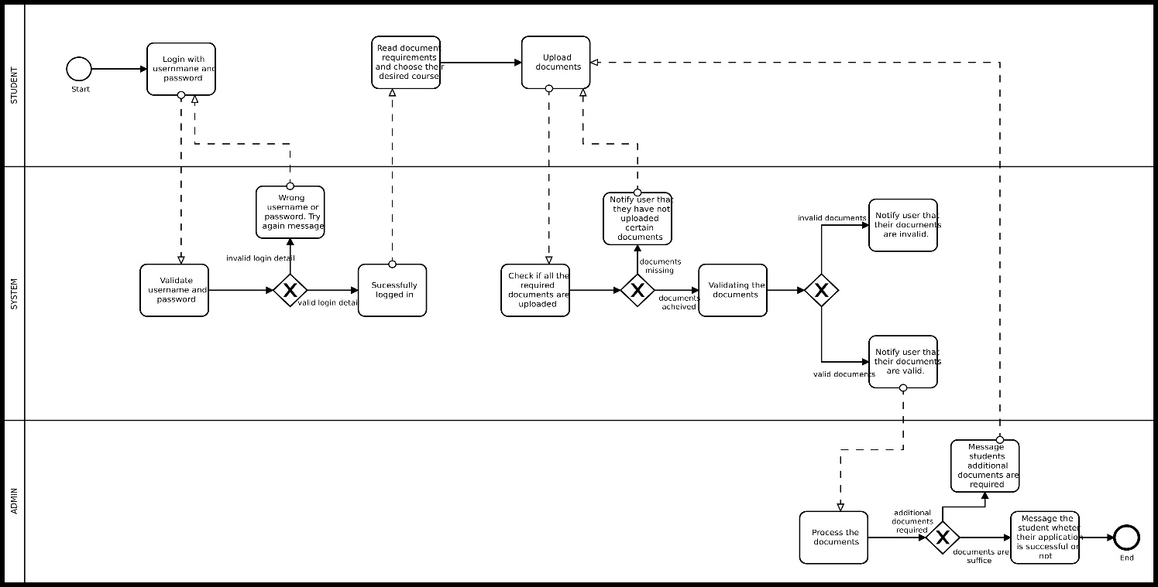

We are developing the application with the use of AGILE SCRUM METHODOLOGY. Here is the brief overview of the scrum life cycle.

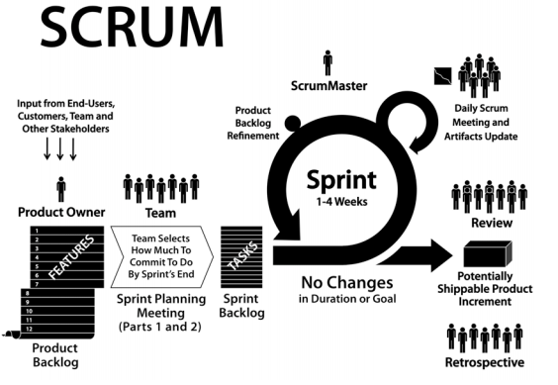

Scrum Methodology divides the project into different sprint and each sprint has its own time period for its completion. Each sprint is well documented and are showcased to the client with their each defined deliverables. Each sprint has four stages of meetings with the team members

1. Sprint planning meeting: - In this meeting, we discuss what are we planning to achieve in this sprint and assign the task to each team member.
2. Standup meeting: - In this meeting, we discuss whether everything is going according to plan or not so that all of the team members are well informed about the progress of the project.
3. Review meeting: - In this meeting, team members deliver their results and receive feedback.
4. Retrospective meeting: - In this meeting, we look back on the process and reflect on what we can improve as a team and implement the improvement for next sprint.

Here is the rough timeline expectation on each of our document completion date.

|  |  |  |
| --- | --- | --- |
| **Task** | **Estimated Time** | **Estimated Completion Time** |
| Initial Product Backlog | 1 Week | 28th August 2020 |
| Initial Project Plan | 1 Week | 29th August 2020 |
| Sprint 1 Documentation and Evidence | 3 Weeks | 11th September 2020 |
| Project Handbook | 5 Weeks | 19th September 2020 |
| Sprint 1 Demonstration | 6 Weeks | 20th September 2020 |
| Sprint 2 Documentation and Evidence | 9 Weeks | 10th October 2020 |
| Product Release | 11 Weeks | 15th October 2020 |